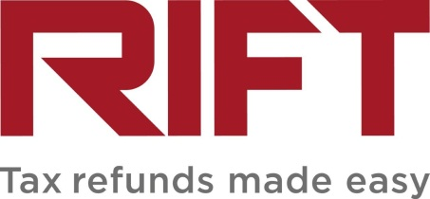
Photo/Video Release Form

This agreement is between and RIFT Ltd.
Address:
Postcode:
Client ref no:
Mobile:
Email:
Date photos/ video taken:
Location of photos/video:
I grant RIFT Ltd use of the photos/video subject to the following conditions:
- I understand that the photos/video taken during this session can be used wholly or in part in any marketing materials that are deemed appropriate by RIFT Ltd. This may include (but is not limited to) leaflets, posters, advertising and social media (Facebook, Instagram, TikTok, YouTube).
- I understand that any testimonial quote I provide may be used in whole or in part, in conjunction with these images/videos or separate from them.
- I understand that my name and refund amount may be included in any photos or videos I provide to RIFT and they will be visible when they are published.
- I understand that my name will be added to the video.
I acknowledge that by signing this form, subject to the usage restrictions above, I give up all claim to ownership of the photos/video, and assign copyright to RIFT Ltd. No further payment will be due. Use of the photos/video will not be granted to third parties.
I have read this form and understand the information. I am 18 years old or over.

Signed__________________________________________________________

Date____________________________________________________________

